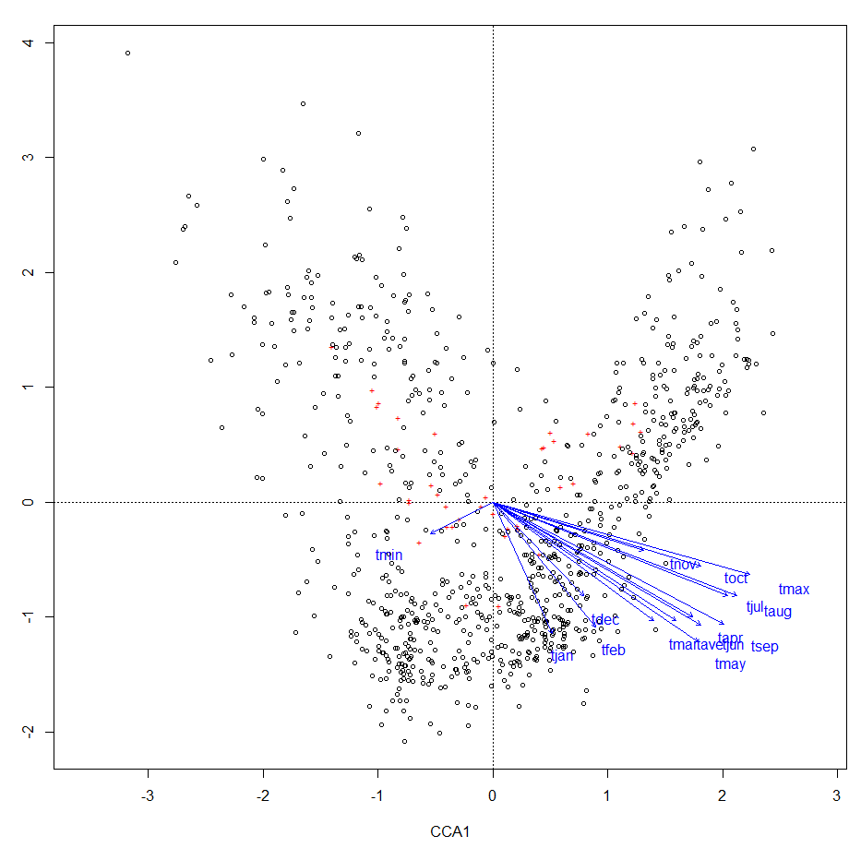

**2. Run CA using function cca (vegan-package). Which temperature variable explains the most variance?**

#which variable explains the most variance?

t_var=c(12:23) #This is grabbing only the monthly temperatures

variable=arctic.env[,t_var]

mod=varpart(sqrt(arctic.pollen),variable$tmay,variable$taug,variable$tsep) # looks like from the triplot that either august, may or september explain the most variance

pl()

plot(mod) #plotting the mod to see which has the most variance

# X1 = tmay, X2 = taug, X3= tsep



**3. How much variance do July and January temperature explain? Determine shared and individual variances:**

#How much variance do July and January temperatures explain?

mod=varpart(sqrt(arctic.pollen),arctic.env$tjun,arctic.env$tjul)

plot(mod)

X1 = tjun, X2=tjul

Looks like tjun explains 6% of the variance, tjuly explains 10% of the variance, and they share a variance of 13% in the arctic pollen data.

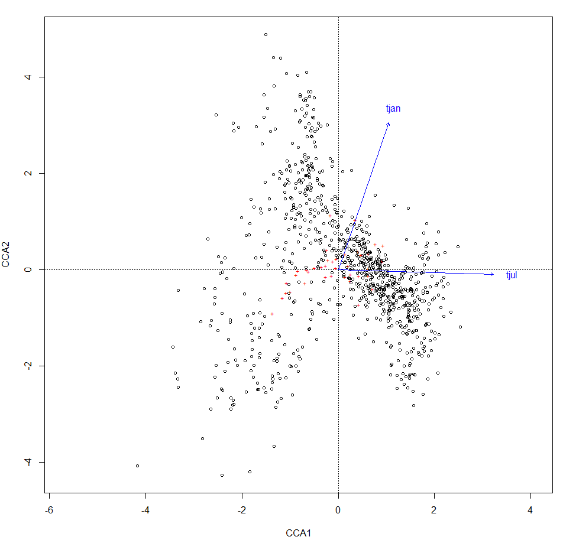

Call: cca(X = arctic.pollen.sqrt, Y = arctic.env.jul.jan)

Inertia Proportion Rank

Total 1.1409 1.0000

Constrained 0.1933 0.1694 2

Unconstrained 0.9476 0.8306 38

Inertia is scaled Chi-square

Eigenvalues for constrained axes:

CCA1 CCA2

0.15308 0.04023

Eigenvalues for unconstrained axes:

CA1 CA2 CA3 CA4 CA5 CA6 CA7 CA8

0.14924 0.09292 0.06445 0.04419 0.03742 0.03528 0.03280 0.03173

(Showing 8 of 38 unconstrained eigenvalues)

**Constrain the arctic pollen data set using January and July temperatures, annual precipitation and July sunshine. How much variance to these variables explain?**

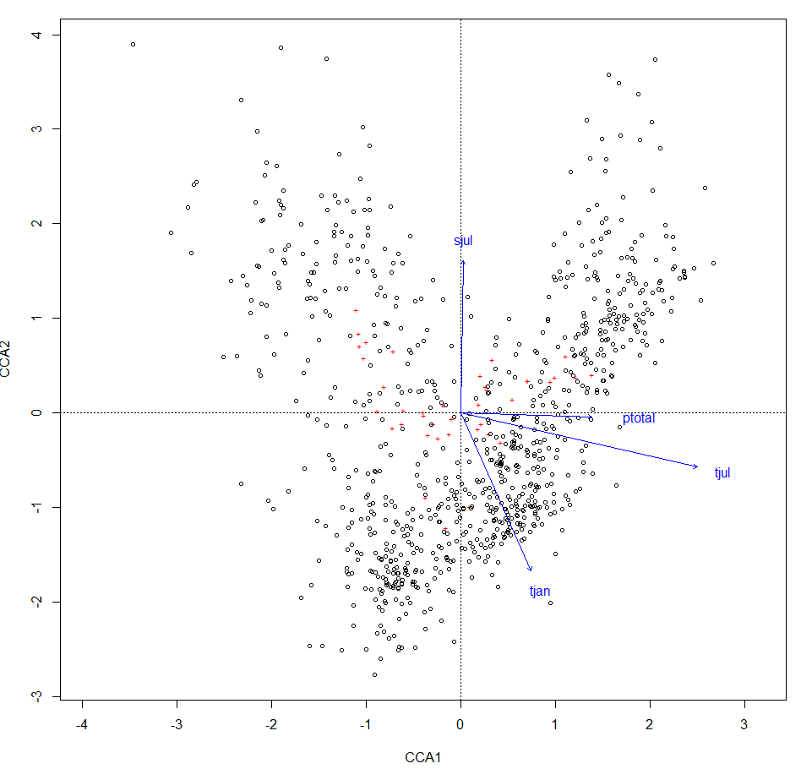Call: cca(X = arctic.pollen.sqrt, Y = arctic.env.update)

Inertia Proportion Rank

Total 1.1409 1.0000

Constrained 0.3003 0.2632 4

Unconstrained 0.8407 0.7368 38

Inertia is scaled Chi-square

Eigenvalues for constrained axes:

CCA1 CCA2 CCA3 CCA4

0.18623 0.06987 0.02958 0.01459

Eigenvalues for unconstrained axes:

CA1 CA2 CA3 CA4 CA5 CA6 CA7 CA8

0.08071 0.06992 0.06444 0.04416 0.03502 0.03424 0.03244 0.03084

(Showing 8 of 38 unconstrained eigenvalues)

**Ordsurf of tjan:**

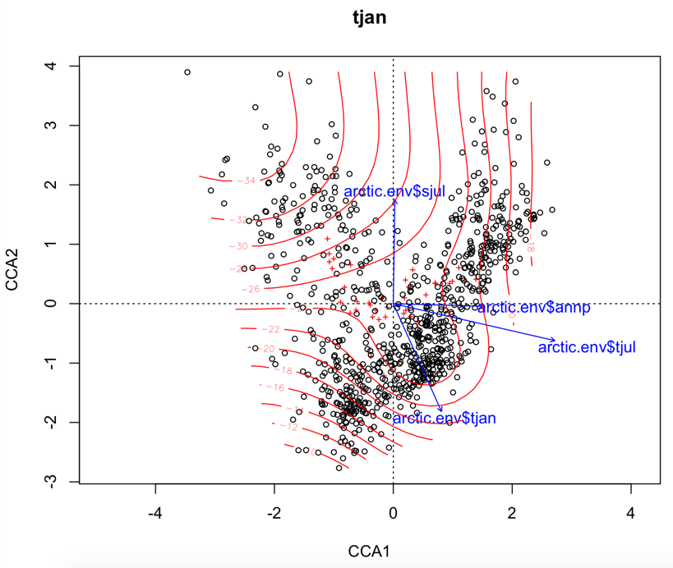

**Ordsurf of tjul:**



**Ordsurf of annual precipitation:**



**Ordsurf of July sunshine:**



**Make a tri-plot of the last ordination and explain the tri-plot**

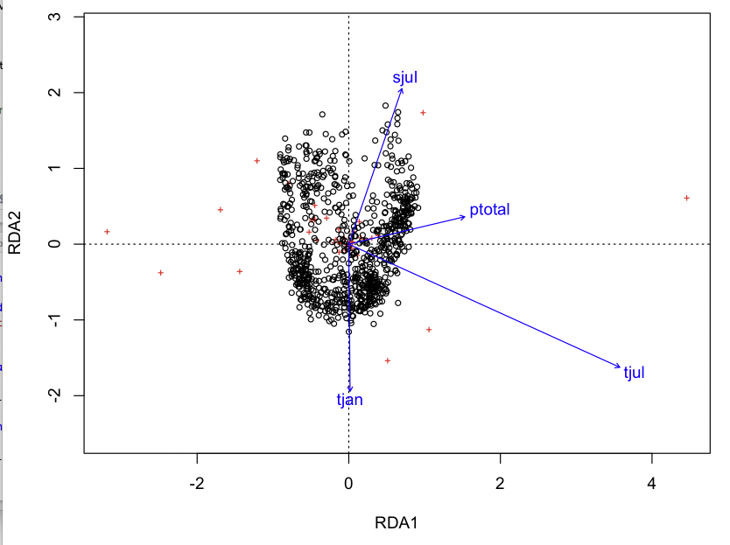

**Plot abundances of taxa F.Cype, F.BBET, F.PPIC, F.PPIN as a function of July temperature:**



#plot the species

par(mfrow = c(2,2))

x=arctic.env$tjul

y1=arctic.pollen$F.CYPE

y2=arctic.pollen$F.BBET

y3=arctic.pollen$F.PPIC

y4=arctic.pollen$F.PPIN

plot(x,y1,main="F.CYPE")

plot(x,y2,main="F.BBET")

plot(x,y3,main="F.PPIC")

plot(x,y4,main="F.PPIN")

**Estimate WA optima and tolerances for these taxa:**

#Optima: Computes weighted average optima and tolerance ranges from species

#abundances and values of the environment.

#WA optima

#Figuring out the optima

opt_cyp=optima(arctic.pollen$F.CYPE,env=arctic.env$tjul)

opt.bbet=optima(arctic.pollen$F.BBET,env = arctic.env$tjul)

opt.ppic=optima(arctic.pollen$F.PPIC,env=arctic.env$tjul)

opt.ppin=optima(arctic.pollen$F.PPIN,env=arctic.env$tjul)

opt_cyp

Weighted Average Optima For: arctic.env$tjul

[1] 7.963289

opt.bbet

Weighted Average Optima For: arctic.env$tjul

[1] 10.51463

opt.ppic

Weighted Average Optima For: arctic.env$tjul

[1] 11.69087

opt.ppin

Weighted Average Optima For: arctic.env$tjul

[1] 12.10854

>

#WA Tolerances

#Running tolerances

tol.cyp=tolerance(arctic.pollen$F.CYPE,env=arctic.env$tjul)

tol.cyp

Weighted Average Tolerances For: arctic.env$tjul

[1] 2.807172

tol.bbet=tolerance(arctic.pollen$F.BBET,env=arctic.env$tjul)

tol.bbet

Weighted Average Tolerances For: arctic.env$tjul

[1] 3.127384

tol.ppic=tolerance(arctic.pollen$F.PPIC,env=arctic.env$tjul)

tol.ppic

Weighted Average Tolerances For: arctic.env$tjul

[1] 2.819576

tol.ppin=tolerance(arctic.pollen$F.PPIN,env=arctic.env$tjul)

tol.ppin

Weighted Average Tolerances For: arctic.env$tjul

[1] 4.936146

## convert to data frame

as.data.frame(opt)

as.data.frame(tol)

## bootstrap WA optima - 100 resamples too low for SD & pCI

bopt <- optima(pollen.percent, july.temp, boot = TRUE, nboot = 100)

head(bopt)

|  |
| --- |
| > as.data.frame(opt)  Opt  F.CYPE 7.641157  F.BBET 6.246450  F.PPIC 7.095561  F.PPIN 36.505232  > as.data.frame(tol)  Tol  F.CYPE 2.899226  F.BBET 3.175763  F.PPIC 3.018677  F.PPIN 5.152283  >  > ## bootstrap WA optima - 100 resamples too low for SD & pCI  > bopt <- optima(pollen.percent, july.temp, boot = TRUE, nboot = 100)  > head(bopt)  Optima optBoot optSD 2.5% 97.5%  F.CYPE 7.641157 7.641546 0.1285184 7.414044 7.889076  F.BBET 10.245100 10.251335 0.1239822 9.990094 10.436629  F.PPIC 11.403328 11.405394 0.1093625 11.202869 11.611372  F.PPIN 11.157035 11.119036 0.4437395 10.259246 11.834041 |
|  |
| |  | | --- | | > | |